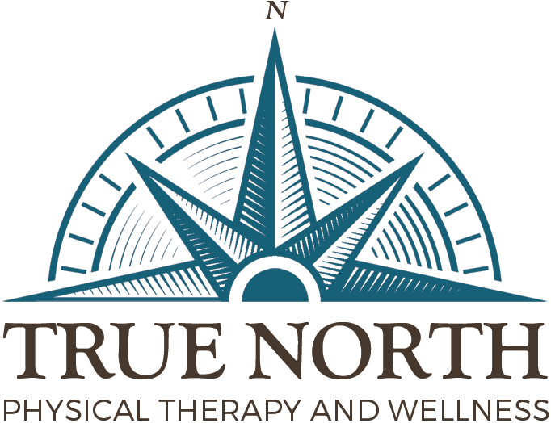
PRIVACY STATEMENT

I understand that under the Health Insurance and Portability & Accountability Act of 1996 (HIPPA), I have certain rights to privacy regarding my protected health information. I understand this information can and will be used to conduct, plan and direct treatment and follow-up care among the multiple healthcare providers who may be involved in that treatment directly and indirectly.

TRUE NORTH Physical Therapy and Wellness, LLC has informed me of the Notice of Privacy Practices that contains a more complete description of the uses and disclosures regarding my health information. I have been given the right to review Notice of Privacy Practices prior to signing this consent. I understand that this organization has the right to change its Notice of Privacy Practices from time to time.

I understand that I may request in writing that you restrict how my private information is used or disclosed to carry out treatment, payment, or healthcare operations. I also understand you are not required to agree with my requested restrictions, but if you do agree that you are bound to abide by such restrictions.

I authorize the release of medical records from TRUE NORTH Physical Therapy and Wellness, LLC to the referring and family physician and to my insurance company, if applicable. I will allow this to occur through fax transmittal, if necessary.

I understand that I may revoke this consent in writing at any time, except to the extent that you have taken action relying on this consent.

Client Signature:______________________________________________Date:___________________
Client Name in Print:_________________________________________________________________

