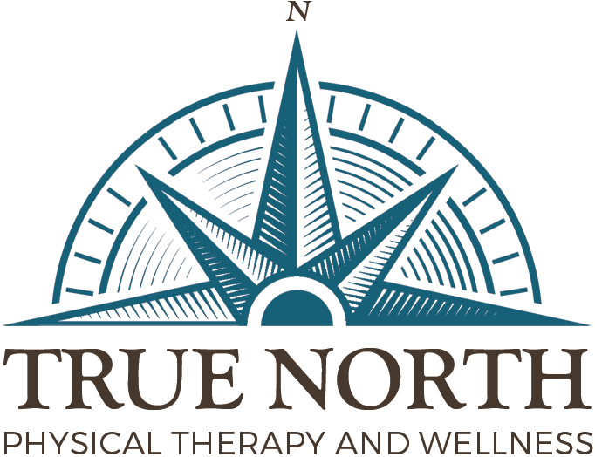

Medically Informed Consent and Release of Records

As a client of TRUE NORTH PHYSICAL THERAPY and WELLNESS, LLC., I voluntarily consent to treatment received, whether as Physical Therapy or Wellness.

I am aware that the practice of physical therapy is not an exact science and I acknowledge that no guarantees have been made to me as to the results of these services. It is the practitioner’s sincere intent to assist and educate me throughout the treatment process.

I understand that if I have any questions regarding treatment techniques, exercise or movement techniques it is my responsibility to ask the practitioner for clarification. This is to ensure the practitioner clarifies treatment techniques, and that exercise objectives are properly performed so that accurate movement re-education occurs.

I understand that TRUE NORTH will adhere to privacy standards required for personal health records. By signing below, I authorize the release of all medical records to the referring physician and to my insurance company, if applicable. I authorize fax transmittal of my medical records, if necessary.

I have read and fully understand the above consent for treatment, release of medical information and insurance authorization.
I will permit a copy of this authorization in place of an original. This authorization may be revoked by my, in writing, at any time.

Acknowledgement of Receipt of Notice, Privacy Practices
True North Physical Therapy and Wellness, LLC

I hereby acknowledge that I have been provided a copy of this medical practice’s Notice of Privacy Practices. Caroline S Choppa, PT Privacy Officer

Patient Printed Name:____________________________________________
Patient Signature:________________________________________________
Date:___________________________________________________________

